SIMATS ENGINEERING
ASSESSMENT TOOL 2

COURSE NAME: Database Management Systems COURSE CODE: CSA0509

COURSE OUTCOME COVERED

CO2: Apply the relational model, relational algebra, SQL query structures, and views to solve database querying and data manipulation problems. (BL3, BL6)

Activity Tool : Scenario-Based Task (Medium) Assessment Tool Weightage: 20%

QUESTIONS
Q.N o | Question | Bloom's Level
1 | A university stores student and course data in a single table. Analyze the structure and identify normalization issues, then redesign it up to 3NF | . BL4 – Analyze
2 | A company database contains employee and department details. Design appropriate SQL queries to retrieve employees working in multiple departments and justify your approach | . BL6 – Create
3 | Given a relation with multiple functional dependencies, determine the candidate keys and check whether the relation satisfies BCNF. If not, decompose it. | BL5 – Evaluate
4 | A banking system requires secure data access. Design views and constraints to ensure data security and integrity for different types of users. | BL6 – Create
5 | A sales database contains redundant data leading to anomalies. Analyze the schema and apply normalization up to 3NF or BCNF to eliminate redundancy. | BL4 – Analyze
6 | Given a dataset of customers and orders, write SQL queries using joins and subqueries to retrieve meaningful information such as frequent customers. | BL3 – Apply
7 | A relation contains multi-valued dependencies. Analyze the structure and decompose it into 4NF, explaining the reasoning. | BL4 – Analyze
8 | A database designer used improper constraints, leading to inconsistent data. Evaluate the schema and suggest appropriate integrity constraints. | BL5 – Evaluate
9 | For a given relational schema, analyze the presence of join dependencies and decompose it into 5NF to remove redundancy. | BL6 – Create
10 | A system uses inefficient SQL queries for data retrieval. Analyze the queries and optimize them using joins, indexing concepts, or query restructuring. | BL5 – Evaluate

Code of Conduct:

I AKCHAYADEVI.G(192524501) _ (Name / Reg No) certify that this
submission is my original work and that I have adhered to the guidelines specified for this assessment. I understand that any violation of academic integrity rules will result in disciplinary action.
AKCHAYADEVI.G
Signature of the student:

QUESTION: 1
A university stores student and course data in a single table. Analyze the structure and identify normalization issues, then redesign it up to 3NF
BEFORE NORMALIZATION:
StudentID | StudentName | Dept | CourseID | CourseName | Faculty | FacultyPhone
S101 | Rahul | CSE | C101 | DBMS | Dr.  Kumar | 9876543210
S101 | Rahul | CSE | C102 | Operating  System | Dr. Priya | 9123456780
S102 | Anitha | IT | C101 | DBMS | Dr.  Kumar | 9876543210

Problems in the Table
- Data redundancy (Student details repeated)
- Course details repeated. 3. Faculty details repeated.
- Update anomaly.
- Insertion anomaly.
- Deletion anomaly.
Functional Dependencies
- StudentID → StudentName, Dept
- CourseID → CourseName, Faculty
- Faculty → FacultyPhone Candidate Key:
(StudentID, CourseID) Step 1: First Normal Form (1NF) • Remove repeating groups.
- Store atomic values only.

StudentID | StudentName | Dept | CourseID | CourseName | Faculty | FacultyPhone
S101 | Rahul | CSE | C101 | DBMS | Dr. Kumar | 9876543210
S101 | Rahul | CSE | C102 | Operating  System | Dr. Priya | 9123456780
S102 | Anitha | IT | C101 | DBMS | Dr. Kumar | 9876543210

(Table already satisfies 1NF.)

Step 2: Second Normal Form (2NF) Remove partial dependency.
StudentID | StudentName | Dept
S101 | Rahul | CSE
S102 | Anitha | IT

COURSE
CourseID | CourseName | Faculty
C101 | DBMS | Dr. Kumar
C102 | Operating System | Dr. Priya

ENROLLMENT
StudentID | CourseID
S101 | C101
S101 | C102
S102 | C101

Step 3: Third Normal Form (3NF) Remove transitive dependency.
FACULTY

FacultyID | FacultyName | FacultyPhone
F101 | Dr. Kumar | 9876543210
F102 | Dr. Priya | 9123456780

COURSE

CourseID | CourseName | FacultyID
C101 | DBMS | F101
C102 | Operating System | F102

Final 3NF Schema

Student(StudentID, StudentName, Dept)

Faculty(FacultyID, FacultyName, FacultyPhone)

Course(CourseID, CourseName, FacultyID)

Enrollment(StudentID, CourseID)

Foreign Keys:
StudentID → Student
CourseID → Course

Advantages
- No redundancy
- No update anomaly
- No insertion anomaly
- No deletion anomaly
- Better consistency
- Improved data integrity

QUESTION: 2
A company database contains employee and department details. Design appropriate SQL queries to retrieve employees working in multiple departments and justify your approach

ANSWER:

TABLES:

Employee

EmpID | EmpName
101 | John
102 | David
103 | Anu
104 | Priya

Department

DeptID | DeptName
D1 | HR
D2 | Sales
D3 | IT

EmployeeDepartment

EmpID | DeptID
101 | D1
101 | D2
102 | D2
103 | D1
103 | D2
103 | D3
104 | D3

Query Explanation
- JOIN combines Employee and EmployeeDepartment tables.
- GROUP BY groups records employee-wise.
- COUNT() counts number of departments.
- HAVING filters employees working in more than one department.
SQL QUERIES:

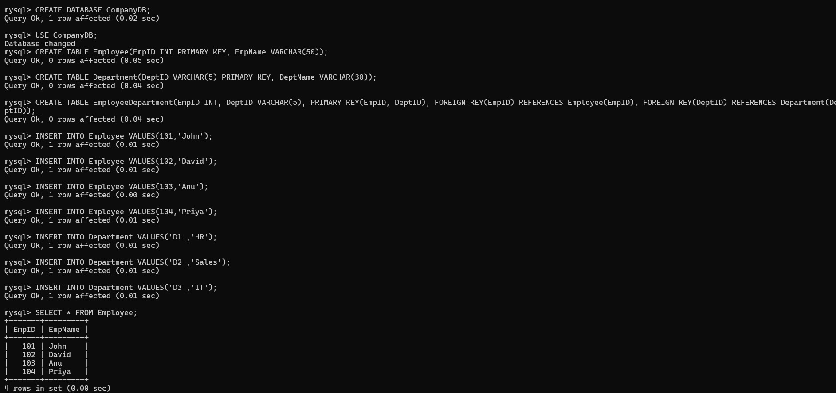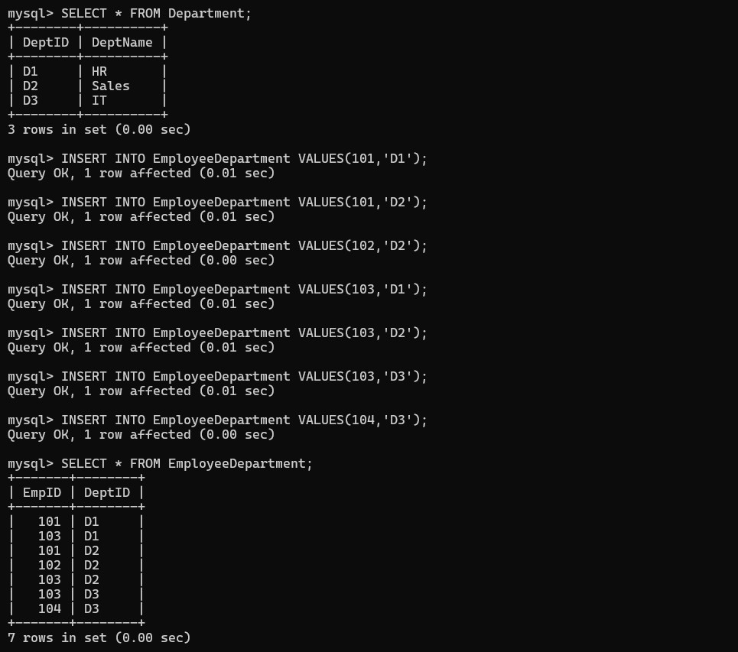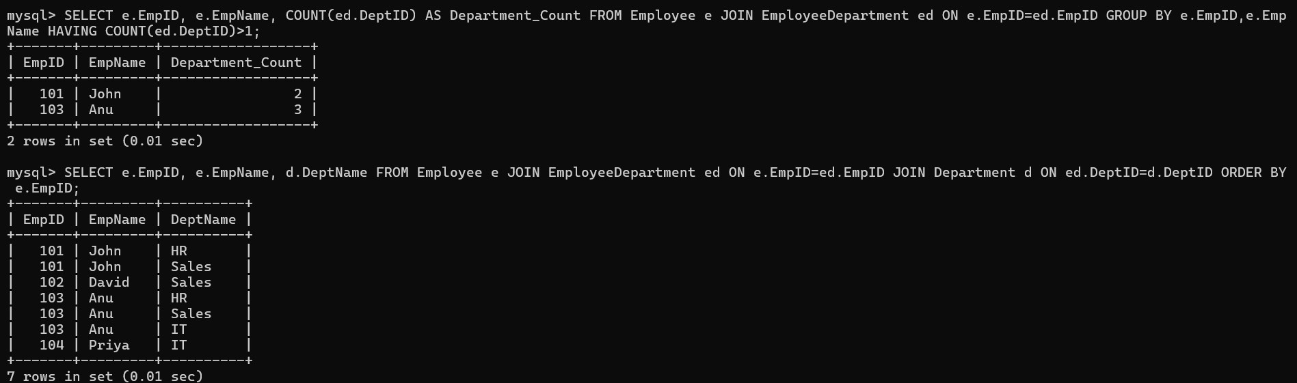

QUESTION:3
Given a relation with multiple functional dependencies, determine the candidate keys and check whether the relation satisfies BCNF. If not, decompose it.
ANSWER:
RELATION: R(A,B,C,D)
Functional Dependencies
- → B
- → C
- → D

Step 1: Find Closure
A+
A+ = A
- → B = A,B
- → C = A,B,C
- → D = A,B,C,D

Therefore, A+ = {A,B,C,D}
HENCE,IDENTITY KEY=A
Prime Attribute A
Non-prime Attributes B C D

BCNF Check BCNF Rule:
For every functional dependency, X → Y X must be a super key.

Dependency 1 A → B
A is Candidate Key
✔ Satisfies BCNF

Dependency 2 B → C
- is NOT Candidate Key
❌ Violates BCNF

Dependency 3 C → D
- is NOT Candidate Key
❌ Violates BCNF

BCNF Decomposition
Relation 1 R1(B,C)
FD B → C
Key B
BCNF ✔

Relation 2 R2(C,D)
FD C → D
Key C
BCNF ✔

Relation 3 R3(A,B)
FD A → B
Key A
BCNF ✔

Final BCNF Relations
R1(B,C) R2(C,D)
R3(A,B)

QUESTION: 4
A banking system requires secure data access. Design views and constraints to ensure data security and integrity for different types of users.
ANSWER:
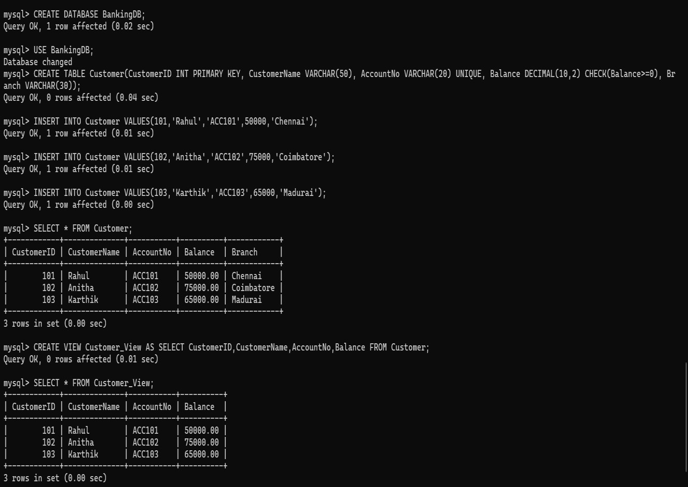

Integrity Constraints Used
- PRIMARY KEY(CustomerID)
- UNIQUE(AccountNo)
- CHECK(Balance>=0)
- NOT NULL (for mandatory fields)
- VIEW hides confidential information from unauthorized users.
Advantages
- Provides secure access.
- Prevents duplicate account numbers.
- Prevents negative balance.
- Improves data integrity.
QUESTION: 5
A sales database contains redundant data leading to anomalies. Analyze the schema and apply normalization up to 3NF or BCNF to eliminate redundancy.
ANSWER:
Unnormalized Relation
OrderID | CustomerID | CustomerName | ProductID | ProductName | SupplierName
O101 | C101 | Rahul | P101 | Laptop | Dell
O102 | C101 | Rahul | P102 | Mouse | Logitech
O103 | C102 | Anitha | P101 | Laptop | Dell
Functional Dependencies
- CustomerID → CustomerName
- ProductID → ProductName, SupplierName
- OrderID → CustomerID, ProductID
Candidate Key OrderID 1NF
OrderI  D | CustomerI  D | CustomerNam  e | ProductI  D | ProductNam  e | SupplierNam e
O101 | C101 | Rahul | P101 | Laptop | Dell
O102 | C101 | Rahul | P102 | Mouse | Logitech
O103 | C102 | Anitha | P101 | Laptop | Dell

2NF
CUSTOMER
CustomerID | CustomerName
C101 | Rahul
C102 | Anitha
PRODUCT
ProductID | ProductName | SupplierName
P101 | Laptop | Dell
P102 | Mouse | Logitech
ORDER
OrderID | CustomerID | ProductID
O101 | C101 | P101
O102 | C101 | P102
O103 | C102 | P101
3NF
CUSTOMER

CustomerID | CustomerName
C101 | Rahul
C102 | Anitha

SUPPLIER

SupplierID | SupplierName
S101 | Dell
S102 | Logitech

PRODUCT

ProductID | ProductName | SupplierID
P101 | Laptop | S101
P102 | Mouse | S102

ORDER

OrderID | CustomerID | ProductID
O101 | C101 | P101
O102 | C101 | P102
O103 | C102 | P101

Final 3NF Schema

Customer(CustomerID, CustomerName)

Supplier(SupplierID, SupplierName)

Product(ProductID, ProductName, SupplierID)

Orders(OrderID, CustomerID, ProductID)

Advantages
- Eliminates redundancy.
- Removes update, insertion, and deletion anomalies.
- Improves consistency. • Ensures data integrity.
- Simplifies maintenance.

QUESTION: 6
Given a dataset of customers and orders, write SQL queries using joins and subqueries to retrieve meaningful information such as frequent customers.

ANSWER:

SQL queries using joins and subqueries to retrieve meaningful information such as frequent customers.

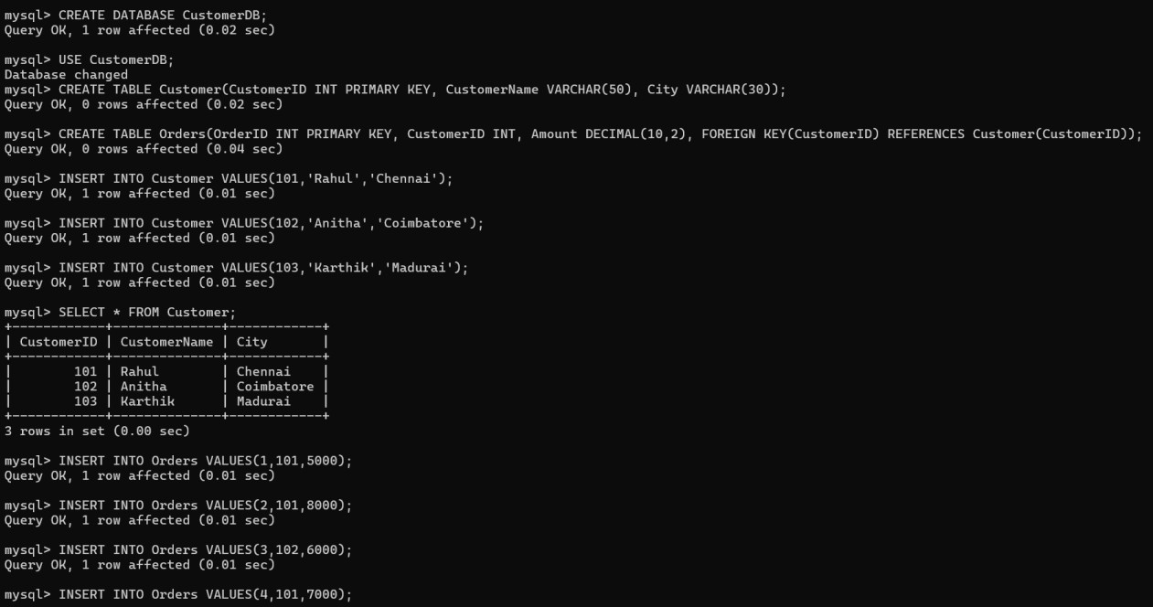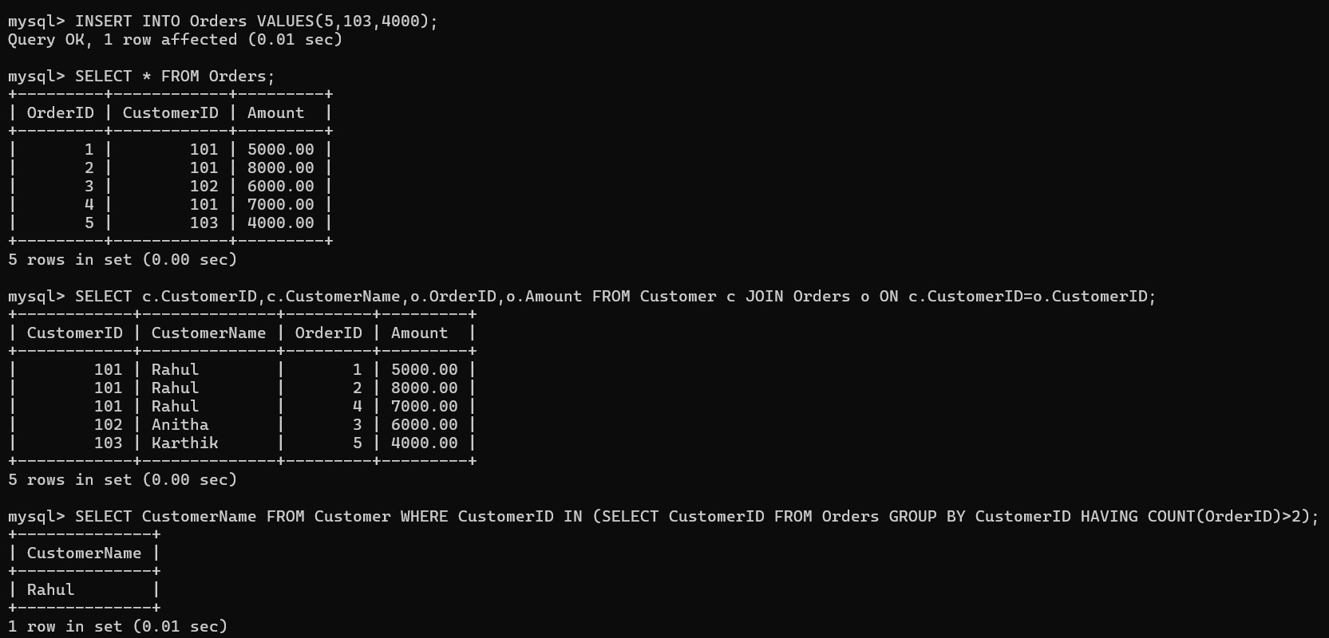

Advantages
- JOIN combines customer and order details.
- Subquery identifies frequent customers.
- GROUP BY groups customer orders.

QUESTION: 7
A relation contains multi-valued dependencies. Analyze the structure and decompose it into 4NF, explaining the reasoning.
ANSWER:

Relation: StudentID, Hobby, Language

StudentID | Hobby | Language
101 | Cricket | English
101 | Cricket | Hindi
101 | Music | English
101 | Music | Hindi
102 | Reading | Tamil
102 | Reading | English

Multi-Valued Dependencies
StudentID →→ Hobby
StudentID →→ Language

Decomposition into 4NF
STUDENT_HOBBY
StudentID | Hobby
101 | Cricket
101 | Music
102 | Reading

STUDENT_LANGUAGE
StudentID | Language
101 | English
101 | Hindi
102 | Tamil
102 | English

Final 4NF Schema

Student_Hobby(StudentID, Hobby)

Student_Language(StudentID, Language)

Reasoning
- The multi-valued dependencies are separated into independent relations.
- Each table contains only one independent multi-valued fact.
- Redundancy is eliminated.
- Update, insertion, and deletion anomalies are removed.
Advantages
- Eliminates redundancy caused by multi-valued dependencies.
- Improves consistency.
- Simplifies maintenance.
- Preserves data integrity.
- Achieves 4NF.

QUESTION: 8
A database designer used improper constraints, leading to inconsistent data. Evaluate the schema and suggest appropriate integrity constraints.
ANSWER:
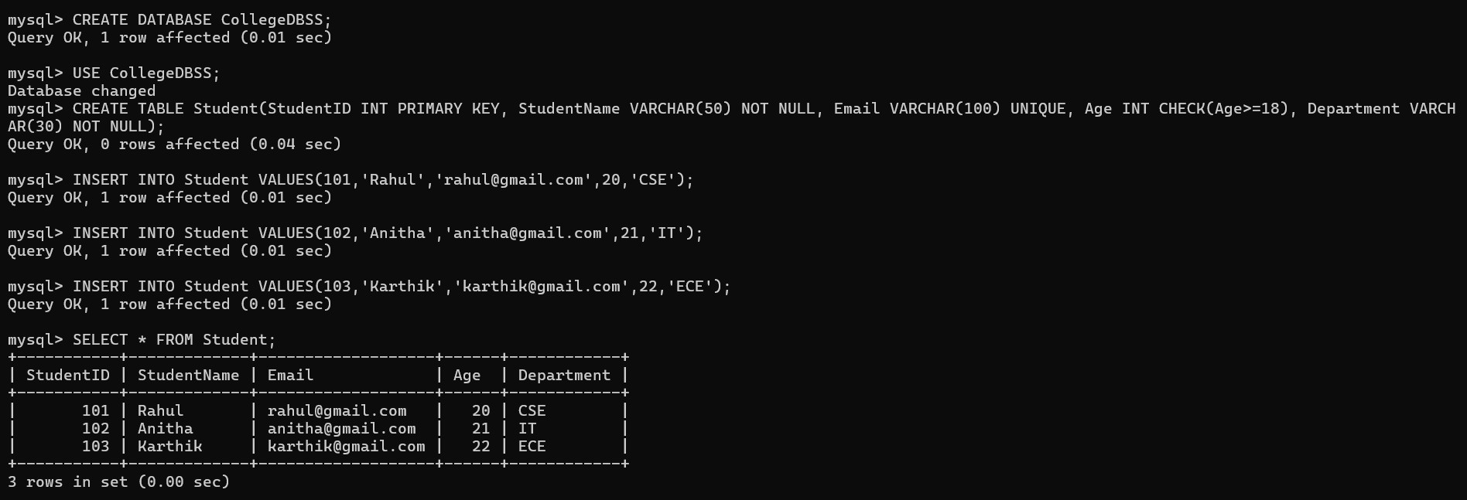
Integrity Constraints Used
- PRIMARY KEY(StudentID)
- NOT NULL(StudentName)
- UNIQUE(Email)
- CHECK(Age >= 18)
- NOT NULL(Department)

Advantages
- Prevents duplicate Student IDs.
- Prevents duplicate email addresses.
- Ensures mandatory fields are not empty. • Restricts invalid age values.
- Maintains data consistency and integrity.

QUESTION:9

For a given relational schema, analyze the presence of join dependencies and decompose it into 5NF to remove redundancy.

ANSWER:

RELATION: SupplierID, PartID, ProjectID

Sample Relation

SupplierID | PartID | ProjectID
S1 | P1 | J1
S1 | P2 | J1
S2 | P1 | J2
S2 | P2 | J2

Join Dependency (SupplierID, PartID, ProjectID)

The relation contains a join dependency, which may introduce redundancy.

Decomposition into 5NF

SUPPLIER_PART

SupplierID | PartID
S1 | P1
S1 | P2
S2 | P1
S2 | P2

SUPPLIER_PROJECT

SupplierID | ProjectID
S1 | J1
S2 | J2

PART_PROJECT

PartID | ProjectID
P1 | J1
P2 | J1
P1 | J2
P2 | J2

Final 5NF Schema
Supplier_Part(SupplierID, PartID)
Supplier_Project(SupplierID, ProjectID)
Part_Project(PartID, ProjectID)
Advantages
- Removes redundancy caused by join dependencies.
- Preserves lossless joins.
- Improves consistency.
- Satisfies Fifth Normal Form (5NF).

QUESTION: 10

A system uses inefficient SQL queries for data retrieval. Analyze the queries and optimize them using joins, indexing concepts, or query restructuring.

ANSWER: SQL queries for data retrieval

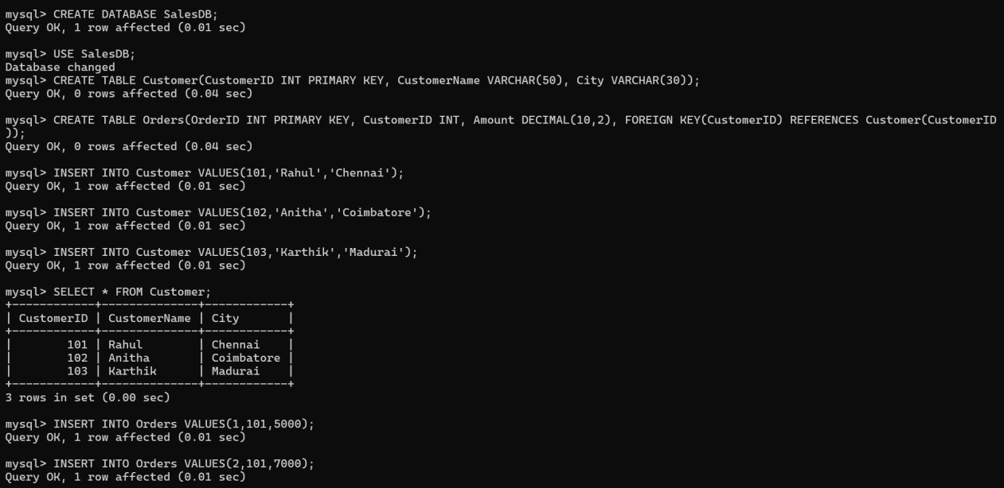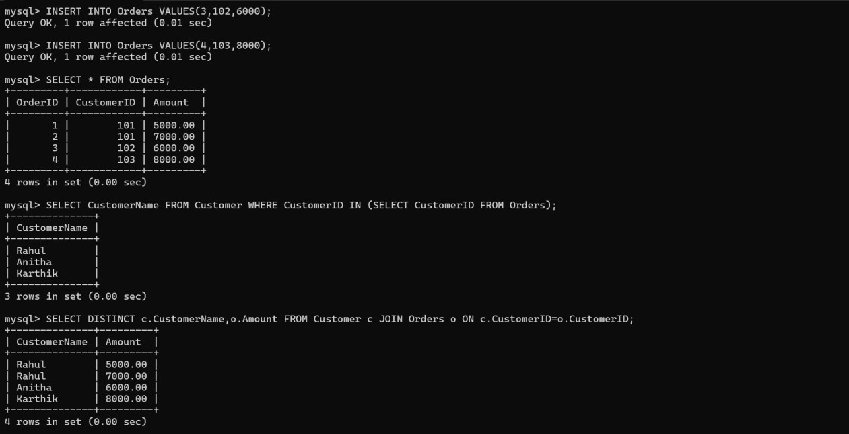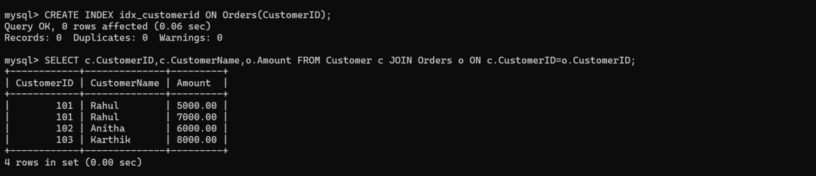
Optimization Techniques Used 1. Replaced the subquery with a JOIN.
- Created an INDEX on CustomerID.
- Used DISTINCT to avoid duplicate customer names.
- Used PRIMARY KEY and FOREIGN KEY for efficient joins.
- Retrieved only the required columns instead of using SELECT *.

Advantages
- Faster query execution.
- Reduced execution time.
- Better index utilization.
- Improved database performance.
- Efficient retrieval of customer and order details.

Conclusion
The inefficient SQL query was optimized by using JOIN, INDEXING, and query restructuring, resulting in faster execution, reduced redundancy, and improved overall database performance.

